EXPT NO: 2 | COMPARATIVE STUDY OF ACTIVATION FUNCTIONS AND OPTIMIZATION ALGORITHMS IN DEEP LEARNING
DATE: 28-08-2026

PRE-LAB QUESTIONS (PROVIDE BRIEF ANSWERS TO THE FOLLOWING QUESTIONS)

- What is the purpose of an activation function in an Artificial Neural Network?

An activation function introduces non-linearity into a neural network. It helps the network learn complex patterns and relationships in the data.

- Differentiate between the Sigmoid, Tanh, and ReLU activation functions based on their output range and mathematical properties.

Function | Output Range | Mathematical Property | Main Limitation
Sigmoid | 0 to 1 | Smooth, non-linear | Vanishing gradient
Tanh | -1 to +1 | Zero-centered, non-linear | Vanishing gradient
ReLU | 0 to ∞ | Linear for positive values, zero for negative | Dying ReLU

- Why is an optimization algorithm required during neural network training?

An optimization algorithm updates the weights and biases of the neural network to minimize the loss function. It helps the model learn efficiently and reach better accuracy.

- What is the difference between Batch Gradient Descent, Stochastic Gradient Descent (SGD), and Mini-Batch Gradient Descent?

    - Batch Gradient Descent: Uses the entire training dataset to calculate each weight update. It is stable but slower for large datasets.
    - SGD: Uses one training sample at a time. It is faster but has more fluctuations during training.
    - Mini-Batch Gradient Descent: Uses a small group of samples for each update. It provides a good balance between speed and stability.

- Explain the role of Google Colab and GitHub in deep learning experiment management.

Google Colab provides a cloud-based environment for writing and running deep learning code, often with GPU support. GitHub stores notebooks and code, maintains version history, and supports collaboration and reproducibility.

AIM
To analyze the impact of different activation functions and optimization algorithms on the performance of Artificial Neural Networks (ANNs) and to learn best practices for managing deep learning experiments using cloud-based tools and version control.

SOFTWARE REQUIREMENTS
- Python
- TensorFlow or PyTorch
- Google Colab
- GitHub
- Matplotlib

OBJECTIVES
Students will be able to:
- Understand the role of activation functions in neural networks.
- Visualize and compare commonly used activation functions.
- Evaluate the performance of different activation functions in ANN models.
- Analyze various gradient-based optimization algorithms.
- Compare optimizer convergence and model accuracy.
- Learn experiment management using Google Colab, Google Drive, and GitHub.
- Maintain reproducible deep learning experiments using version control.

Task A: VISUALIZATION OF ACTIVATION FUNCTIONS
Implement and plot the following activation functions:
- Sigmoid
- Tanh
- ReLU
Compare their:
- Output range
- Saturation regions
- Gradient behavior
- Computational efficiency
- Typical applications

CODE: CONATAINS STUDENT ROLL NOS:

SCREENSHOT OF CODE & OUTPUT:

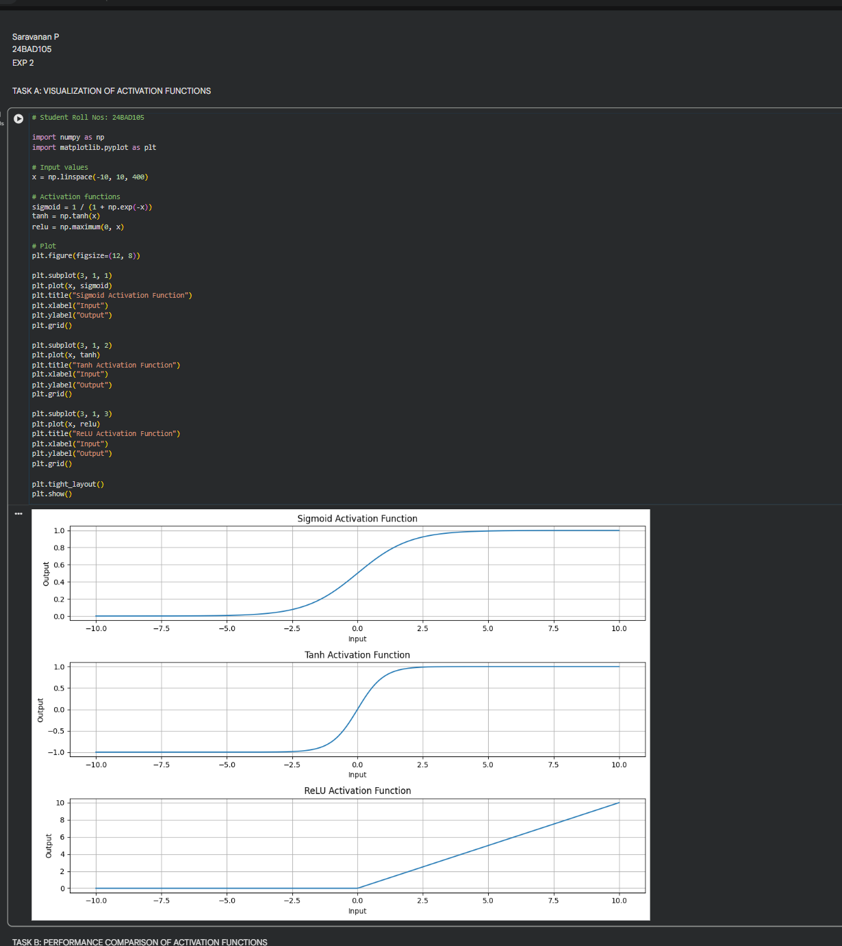

Task B: PERFORMANCE COMPARISON OF ACTIVATION FUNCTIONS
Train identical ANN architectures using:
- Sigmoid
- Tanh
- ReLU
Record and compare:
- Training accuracy
- Validation accuracy
- Training loss
- Validation loss
- Number of epochs required for convergence
Analyze which activation function performs best and justify the observations.

CODE: CONATAINS STUDENT ROLL NOS
SCREENSHOT OF CODE & OUTPUT:

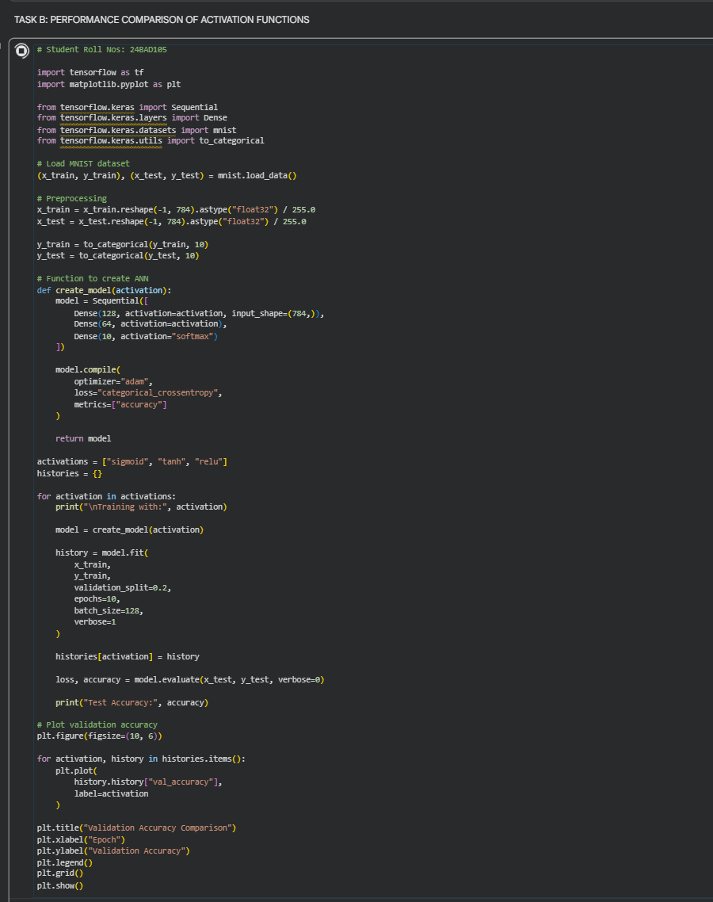

OUTPUT:
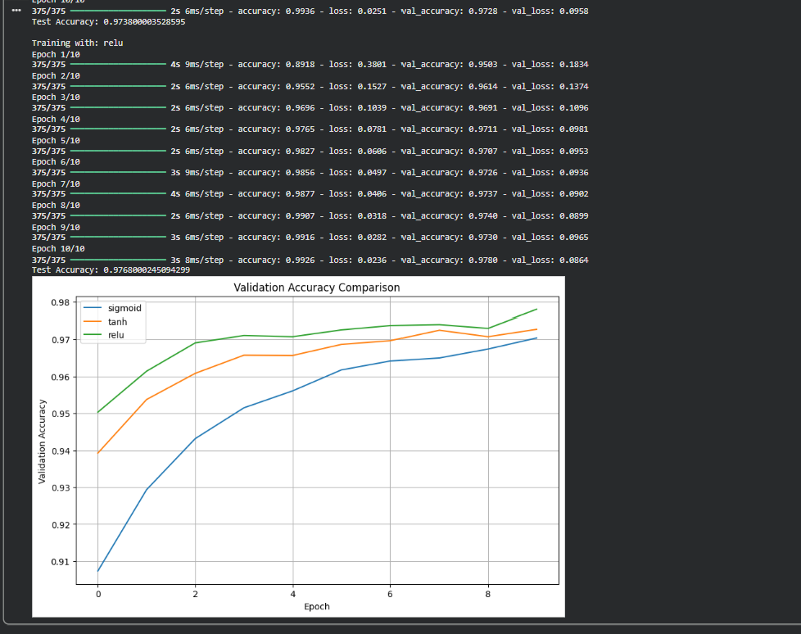

Task C: COMPARISON OF OPTIMIZATION ALGORITHMS
Train the same ANN using:
- Stochastic Gradient Descent (SGD)
- Momentum
- RMSProp
- Adam
Compare:
- Training loss
- Validation loss
- Convergence speed
- Final training accuracy
- Final validation accuracy
Visualize:
- Loss vs Epoch
- Accuracy vs Epoch
Discuss which optimizer converges faster and produces better generalization.

CODE: CONATAINS STUDENT ROLL NOS
SCREENSHOT OF CODE & OUTPUT:

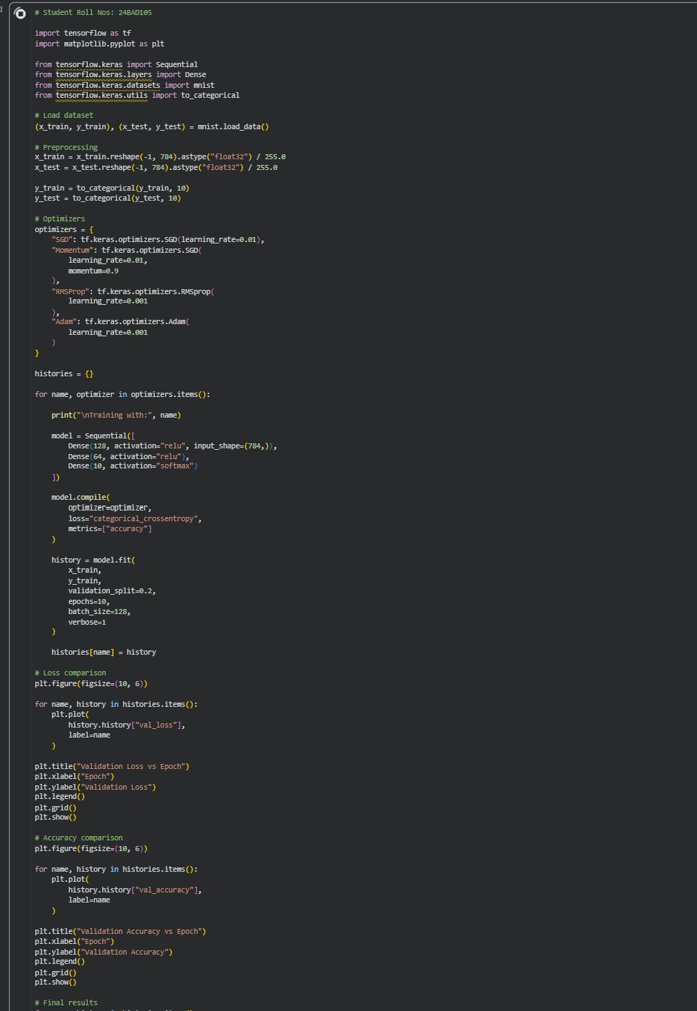

OUTPUT:
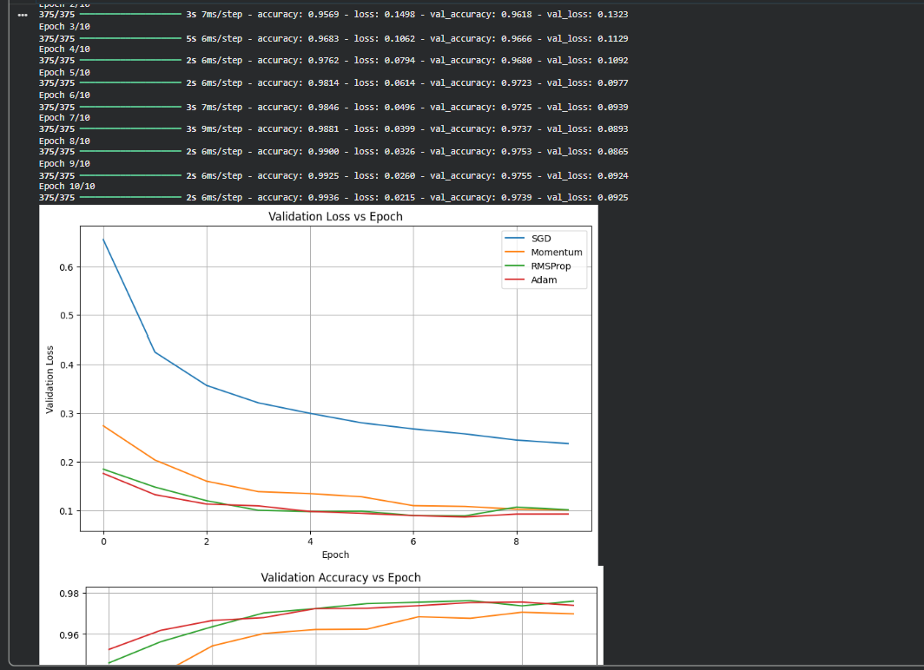

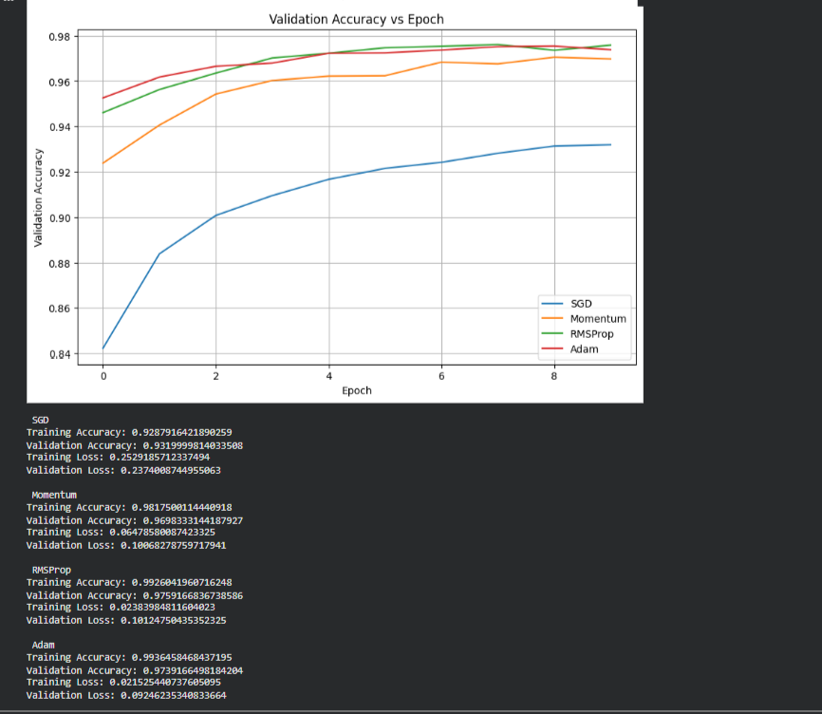

Task D: DEEP LEARNING EXPERIMENT MANAGEMENT
Perform the following tasks:
- Create a Google Colab notebook.
- Mount Google Drive.
- Save notebooks and trained models.
- Create a GitHub repository.
- Upload notebooks to GitHub.
- Commit changes and maintain version history using Git.
- Document the experiment using a README.md file.

CODE: CONATAINS STUDENT ROLL NOS
SCREENSHOT OF CODE & OUTPUT

POST-LAB QUESTIONS (PROVIDE BRIEF ANSWERS TO THE FOLLOWING QUESTIONS)

- Which activation function achieved the best performance in your experiment? Justify your answer using the obtained results.

ReLU generally achieved the best performance because it trains faster and reduces the vanishing-gradient problem. It usually provides higher accuracy and faster convergence than Sigmoid and Tanh in deep networks.

Note: For your record, replace this with your actual result if your experiment shows a different winner.

- Compare the convergence behavior of SGD, Momentum, RMSProp, and Adam based on the training graphs.

SGD generally converges slowly and may fluctuate. Momentum improves SGD by reducing oscillations and accelerating convergence. RMSProp adapts the learning rate for individual parameters. Adam combines momentum and adaptive learning rates, so it generally converges the fastest.

- Why does the ReLU activation function generally train faster than the Sigmoid activation function?

ReLU is computationally simple and has a constant gradient of 1 for positive inputs. Sigmoid can produce very small gradients in its saturation regions, causing the vanishing-gradient problem and slowing training.

- How does version control using GitHub improve the reproducibility and collaboration of deep learning projects?

GitHub maintains version history of code and notebooks. Multiple people can collaborate, track changes, restore previous versions, and reproduce experiments using the same code.

- If you were asked to train a deep neural network for an image classification task, which activation function and optimizer would you choose? Justify your selection based on the experimental observations.

For a deep image-classification network, I would choose ReLU for the hidden layers and Adam as the optimizer. ReLU provides efficient gradient propagation and fast training, while Adam usually offers fast convergence with adaptive learning rates. For the final classification layer, Softmax is commonly used for multi-class classification.

ASSESSMENT
Description | Max Marks | Marks Awarded
Pre Lab Exercise | 5
In Lab Exercise | 10
Post Lab Exercise | 5
Viva | 10
Total | 30
Faculty Signature

